 | 中州航空飞行员履历登记表  PILOT APPLICATION FORM-CENTRAL AIRLINES
基本信息
GENERAL INFORMATION
照片 Photo | 全名  （与CAAC执照名字/境外执照一致）  Full Name  (Must match CAAC License / as per latest  foreign license if no CAAC license) |  |  | 姓氏（与护照姓氏  一致）  Surname  (As Per Passport) |  | 名字（与护照名字  一致）  Given Names  (As Per Passport)
 | 年龄 Age |  |  | 出生年月日  Date ofBirth  (Y/M/D) |  | 性别 Gender
 | 现国籍  Present Nationality |  |  | 出生地  Place of Birth |  | 宗教 Religion
 | 护照号  PASSPORT No. |  |  | 签发日期  Issue Date:(Y/M/D) |  | 有效期至  Exp Date: (Y/M/D)
婚姻状况 Marital Status |  | 子女 Children |  | 身高  Height in CMs |  | 体重  Weight in KGs
邮件  E-mail |  | 联系电话 Phone No. |  | 地址  Home Address
飞行基本信息
BASIC FLIGHT INFORMATION
原工作单位  Original Work Unit |  |  | 现技术标准  Current Technical Standards  (Captain / Cruise Captain / First Officer) |  |  | 现飞本机型 Current Type  Ratings
获取航线执照日期 Date of acquiring the  airline license(Y/M/D) |  | 首聘机长日期  Date of First Appointment as Captain  (Y/M/D) |  |  | 教员签注有效期  Instructor Endorsement Validity Period  (Y/M/D-Y/M/D)
是否持有CAAC-ICAO英  语等级级别  CAAC-ICAO English  Language Proficiency level  lYes / No] |  | CAAC-ICAO英语等级到期日  CAAC-ICAO English Level Expiry Date  (Y/M/D) |  |  | 现ICAO英语等级级别  Current ICAO English Level
飞行经历
FLYING EEXPERIENCE
现总飞行时间  Current total flying hours in  your career: | H |  | 现总飞行经历时间  Current total flying experience hours in  your career: |  | H | 现总起落数  Current Total  Number of Landings
请仅填写121部运行的飞行机型经历，尽可能详细列出多种机型并分别说明。
同时，请提供相关的飞行记录本（logbook）、飞行时间证明、无事故证明以及奖惩情况证明。
Only list flight hours under CCAR 121 operations. Please list as many aircraft types as possible and provide detailed information for each.
`Additionally, submit: relevant Logbooks； Flight Time certificates, Incident-Free Declaration and Punishments Records.
工作单位(国家) Name of Company  (Country) | 起始年月日  From  (Y/M/D) | 截止年月日  To  (Y/M/D) | 所飞机型 A/C Type | 机型飞行经历时间  Total Flying  Experience Time | 带队机长时间  PIC Time | 副驾驶时间 FO Time | 教员时间  Instructor Time
总时间  TOTALS(H) |  |  |  | H | H | H | H

离职概述
RESIGNATION OVERVIEW
是否离职  Resignation: [Yes/No] | 离职日期  Contract Ended: (Y/M/D) |  | 离职周期  Notice Period:  [X] months/weeks |  | 最近一次上座飞行  时间  Date of Last Seated  Flight Time(Y/M/D) | 最近一次熟练检查 Recent Proficiency  Check (PC)  (Y/M/D) | 最近一次航线检查 Recent Line Check  (LC)  (Y/M/D)
离职原因
Reason for Leaving or Note
飞行执照
PILOT FLYING LICENSE
执照类型  License Type/Validations | 签发国家  Licensing Country | 机型签注  Type Ratings  (e.g., B737/A320) | 执照签发开始日  Issue Date:  (Y/M/D) | 执照到期日 Expiry Date：  (Y/M/D) | 执照编号 License No. |  | 限制  Limitations
您过去是否获得过中国执照？  Have you ever obtained Chinese License in the  past?  [Yes/No] |  |  | 是否有CAAC机长航线检查记录  Have you ever obtained CAAC Captain  Line Check Record:  [Yes/No] |  |  | CAAC云执照安全 扣分记录CAAC e-License Safety  Demerit Record
体检合格证
MEDICAL CERTIFICATE
体检合格证类型 |  | 签发国家 |  | 到期日 |  | 限制
Class |  | Country of Issuance |  | Expiry Date：(Y/M/D) |  | Limitations
教育经历
EDUCATION HISTORY
航校培养或军转民  Aviation School Training or Military-to-Civilian  Transition |  |  |  | 最高学历  Highest Education  （ High School / Secondary / Associate /  Bachelor / Master...）
教育经历  EDUCATION HISTORY  (From High School) | 学校名称 School name | 入学时间 FROM (Y/M) | 毕业时间  To (Y/M) | 专业 Major | 是否毕业  Graduated[Yes/No] | 学位 Degree | 备注  Note
航校教育经历  Aerospace School  Education Experience | 学校名称 School name | 入学时间 FROM (Y/M) | 毕业时间  To (Y/M) | 专业 Major | 是否毕业  Graduated[Yes/No] | 学位 Degree | 备注  Note

飞行安全记录
FLIGHT SAFETY RECORD
根据运输飞行员注册、记录和运行管理（AC-121-FS-2014-48号咨询通告）中的第6条，安全记录及人员运行限制的规定，请您如实填写以下信息。
Pursuant to Section 6 (Safety Records and Operational Restrictions) of the Transport Pilot Registration, Records, and Operations Management (Advisory Circular AC-121-FS-2014-48), please provide the following information truthfully and accurately.
编号 Number | 条件 Program | 说明 Define | 是/否 YES/NO | 备注  Note
1 | 重大安全事故  Major safety accidents | 重大安全事故责任人  Person responsible for major safety  accidents
2 | 一般事故  ordinary accident | 一般事故责任人  General accident responsible person
3 | 严重征候  Serious Incident | 严重事故征候责任人  Person in Charge of Serious Incident
4 | 一般征候  Minor Incident | 一般事故征候责任人  Person in Charge of Minor Incident
5 | 差错类事件  Error-related Incidents | 差错类事件责任人（包含严重差错及一  般差错）  Person Responsible for Error-related  Incidents (Including Serious and General  Errors)
6 | 申请材料造假  forgery and an inability to trust the information in applications | 在执照或登记申请过程中提交虚假材料  Submitting false information during the license or registration application process
7 | 警告 Warning | 受到局方警告处罚  Have you ever been cited for violations of  civi/military aviation regulations?
8 | 罚款  Fine | 受到局方罚款处罚  Received fines and penalties from the  bureau
9 | 暂扣执照  Temporary suspension of license | 受到局方暂扣执照处罚  Punished by the bureau for temporarily  withholding licenses
10 | 吊销执照  Revoke a license | 受到局方吊销/撤销执照处罚  Penalty for revocation/revocationof license by the bureau
11 | 实践考试不合格  Failed the practical exam | 含私商仪、初始/转机型/升机长/型别教  员/资质排查及重获资格在内的考试不合  格  Failure in exams including private business  instruments, initial/conversion  models/upgrade captains/type  instructors/recurrenttraining and re  qualification
12 | 熟练检查不合格  Proficiency inspection failed | 含定期检查/熟练检查/资质排查在内的  不合格  Non conformities including regular  inspections/proficiencychecks/Recurrent  Training

13 | 航线检查不合格  Route inspection failed | 含副驾驶升阶段、副驾驶聘机长、机长 升阶段、机长年度航线检查、教员航线 评估及资质排查在内的航线检查不合格  The route inspection, includingthe  promotion stage of the co pilot, the  appointment of the captain by the co pilot,  the promotion stage of the captain, the  annual route inspection of the captain, the  assessment of the instructor's route, and the  qualification investigation, is not qualified
14 | 本场训练评估不合格  This training evaluation is not qualified | 含初始/升机长/资质排查在内的本场训  练评估不合格  This training evaluation, including  initial/captain upgrade/qualification  screening failed
15 | 理论考试作弊  Cheating in theoretical exams | 执照理论考试作弊或局方组织的理论考  试作弊  Cheating in license theory exams or in  theoretical exams organized by the  authorities
16 | PAE、CAE、IRE、ATPL单科补考1次  以上  More than one make-up exam for a single  subject, including PAE、CAE、IRE、  ATPL | 执照理论考试CPL、ATPL、IR单科补考  1次以上  More than one make-up exam for a single  subject, including PAE、CAE、IRE and  ATPL in the license theory exam
18 | ICAO/汉语能力等级考试补考1次以上  More than one make-up exam for  ICAO/Chinese Proficiency level exam | ICAO/汉语能力等级考试补考1次以上  More than one make-up exam for  ICAO/Chinese Proficiency level exam
19 | 跨合格证调动  Cross qualification certificate transfer | 在不同的合格证持有人之间转换注册  Converting registration between different  certificate holders
20 | 出现作风问题  Professional Conduct Violations | 含因工作/生活/思想作风出现问题被公  司或局方处罚  Including being punished by the company or bureau due to issues with  work/life/ideologicalstyle
根据局方规定，以下信息供我司参考，请如实填写。
According to the regulations of the bureau, the following information is for our reference. Please fill it out truthfully.
编号 Number | 说明 Define |  | 是/否 YES/NO | 备注  Note
1 | 是否有飞行经历造假或者核实有飞行经历不符的情形？如是请说明情况。  Have there been instances of falsification or verification offlight experiences that do not match? If so, please explain the situation.
2 | 近5年内是否发生过严重征候或以上的安全事件？如是请说明情况。 Have you had any automobile accidents within the last five years?
3 | 是否在近5年内有因飞行技术停飞或违规违纪受停飞处分？如是请说明情况。 Has your driver's license ever been suspended or revoked within the last five years?
4 | 飞行职业生涯中是否发生过征候或者严重差错？如是请说明情况。  Have there been any accidents or serious errors in your flying career? If so, please explain the situation.
5 | 是否受到过原公司的各种行政处分？如是请说明情况。  Have you ever been subjected to any administrative sanctions from the original company? If so, please explain the situation.
6 | 是否有未通过熟练检查或航线检查的情形？如是请说明情况。  Is there any situation where proficiency checks or route checks have not been passed? If so, please explain the situation.

7 | 是否发生过技术降级的情形？如是请说明情况。  Have you ever been demoted in rank due to proficiency deficiencies?
8 | 是否发生过未通过机长升级检查或者机长聘任检查的情形？如是请说明情况  Has there been any situation where the captain upgrade inspection or captain  appointment inspection has not been passed? If so, please explain the situation.
拟聘飞行员健康调查问卷
Health questionnaire for proposed pilots
please tick "√" to choose "yes" or "no" one by one
请逐项回答下列问题，以打“√”的形式选择“有”或者“无”
编号 Number | 说明 Define | 是/否 YES/NO | 如有异常，请具体说明  If there is any abnormality, please specify
1 | mental disorders 精神障碍
2 | unconsciousness . faint 昏迷 . 晕倒
3 | Inflight or ground incapacitation 空中或地面失能
4 | epilepsy or convulsion 癫痫或抽搐
5 | frequent or severe headache 经常或严重的头痛
6 | head injury 头颅外伤
7 | insomnia .agrypnia 睡眠不良 . 失眠
8 | flight illusion 飞行错觉
9 | abnormal feeling of limbs 肢体感觉异常
10 | accident or accident symptom of flight 飞行事故或事故征候
11 | alcohol or substance dependence or abused 物质依赖或滥用
12 | Precordial distress or Heart disease 心前区不适或心脏病
13 | Hypertension or hypotension 高血压或低血压
14 | Asthma or pneumopathy 哮喘或肺脏疾病
15 | Gastrointestinal diseases 胃肠疾病
16 | Diabetes 糖尿病
17 | allergic diseases 过敏性疾病
18 | cholelith or gall system disease 胆道结石或胆系疾病
19 | kidney stone or hematuria 泌尿系结石或血尿
20 | history of injury or surgery operation 手术或外伤史
21 | pains of waist , back , or lamb joints 腰背四肢关节痛
22 | gynecology diseases 妇产科疾病
23 | tinnitus or hearing loss 听力下降或耳鸣
24 | Barotrauma (Ear Pressure Injury) 压耳
25 | Motion Sickness (Airsickness) 晕机
26 | vertigo , dizziness 头晕
27 | Dysopia or oculopathy 视觉障碍或眼部疾
28 | surgery of myopia 近视眼手术矫治
29 | wear lens/glasses 佩戴眼镜
30 | What is your degree of myopia? 你近视度数是多少？

31 | frequent usage of sleeping medicine or tranquiliser 频繁使用安眠药物或镇定剂
32 | current usage of drugs 目前使用药物
33 | infectious disease 传染病
a. AIDS
a.艾滋病
b. Syphilis
b. 梅毒
c. Genital warts
c. 尖锐湿疣
d. Gonorrhea
d. 淋病
34 | hospitalizing history in recent 1 years 近一年住院史
35 | vacation or rehabilitasion after illness in recent 1 years 近一年疗养史
36 | Fatigue 疲劳感
37 | Smoking 吸烟
38 | Others 其他
39 | Family History of Certain Diseases(first time application only) 首次申请时填写以下疾病家族史
a. cardiovascular diseases
a. 心血管疾病
b. Diabetes
b. 糖尿病
c. Epilepsy
c. 癫痫
d. mental diseases
d. 精神病
40 | Have you had a lung infection in the past year? 近一年是否有肺部感染？
41 | Have you undergone a chest CT scan? If yes, were any abnormalities detected? 是否做过胸部CT？ 是否异常？
42 | Whether there has been a positive exercise plate (suspicious positi ve 是否出现过运动平板阳性（可疑阳性
43 | Whether you have ever had a sleep disturbance？ 曾经是否出现过睡眠障碍
44 | Are you using insulin to control your blood sugar? 是否有使用胰岛素控制血糖？
45 | What is your BMI? (Weight Kg/Height ㎡） 你 BMI 指数多少？ （体重 Kg/身高㎡ ）
46 | Have you ever had an MRI of your skull? Is it abnormal? 曾经是否做过头颅核磁？ 是否异常？
47 | Is there a history of high blood pressure? What is the daily blood pressure 是否有高血压病史？ 日常血压水平？
48 | Have you ever had an ultrasound of your heart checked? Is it abnor mal? 曾经是否检查过心脏超声？ 是否异常？
49 | Whether the flight has ever been grounded due to health problems 曾经是否因身体健康问题停飞
50 | Have you experienced significant changes in appetite or sleep patterns in the past 6 months?  近期是否存在饮食睡眠问题
（请附CAAC云执照信息页、签注页、扣分页及体检合格证截图）
CAAC License: Submit screenshots ofCAAC Cloud License (info/endorsement/demerits/medicalcert).
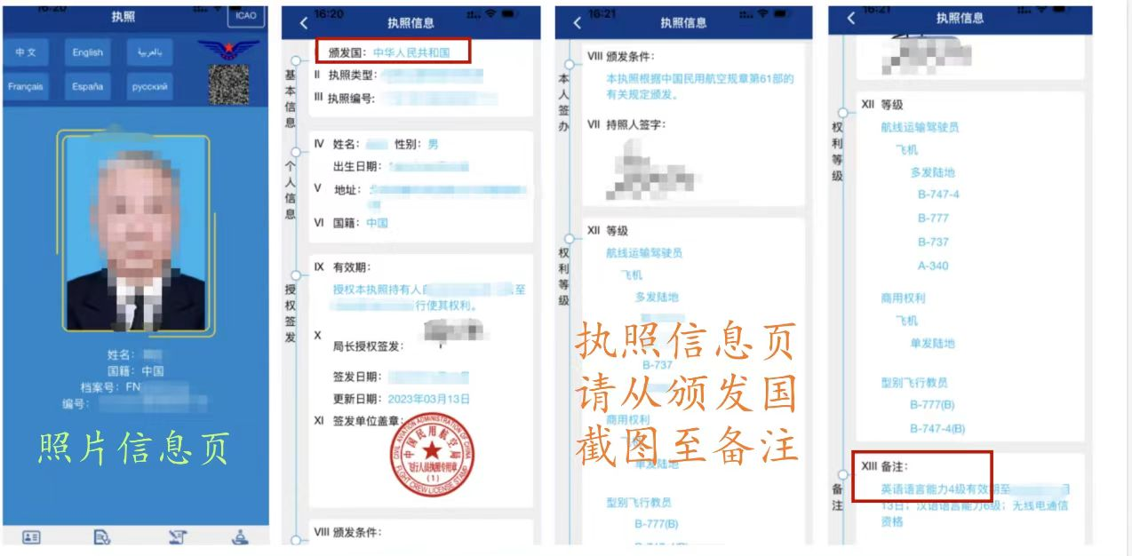

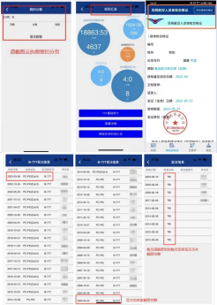
我承诺，以上信息真实可靠，如有虚假，一经局方或公司查出，本人愿意承担任何相关责任
（包括但不限于全额赔偿公司费用及其他赔偿）。
I hereby declare that:
The information provided above is true and accurate to the best of my knowledge. If any falsification is discovered by the authorities or the company, I shall bear full responsibility, including but not limited to full reimbursement of company expenses and any other applicable penalties.
签名（必须手写）  Applicant's Signature  (Handwritten) |  | 日期  Date

备注：所有文件必须按顺序编号命名
（例如：01申请人-简历.xlsx、02申请人-护照.pdf）
Note：All documents must be sequentially numbered in the filename
(e.g., 01Applicant-Application.xlsx, 02Applicant-Passport.pdf).

00.XXX-Blue-background ID photo蓝底正装证件照
00.XXX-White-background ID photo白底正装证件照
01.XXX-Application简历.xlsx
02.XXX-Passport护照
03.XXX-CAAC License中国执照
04.CAAC Medical Certificate CAAC体检合格证
05.CAAC ICAO English Level CAAC英语等级
06.Flight hours，No-accident record，Discipline report by the Former Chinese Airline
中国原航司单位提供的飞行经历时间证明、无事故记录证明、奖惩证明
07.Resignation Certificate Issued by the Former Chinese Airline
中国原航司单位离职证明
08.XXX-Foreign License-ATPL 境外飞行执照
09.Foreign Medical Certificate 境外体检合格证
10.Logbook飞行经历记录簿
11.Additional Supporting Documents其它补充材料

